Assignment – 14 (Entering, Deleting, and Updating Data)
1️.Write a command that inserts the following values into the salespeople table, in this order: city = San Jose, name = Blanco, commission = NULL, salesperson number = 1100.
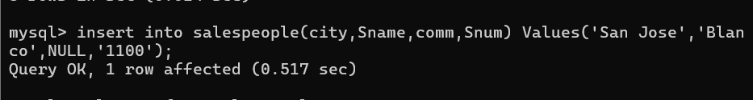
2️.Write a command that deletes all orders belonging to the customer named Clemens from the Orders table.
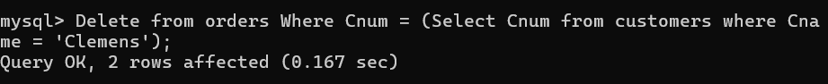
3️.Write a command that increases the rating of every customer who lives in Rome by 100.
4️.Salesperson Serres has left the company. Write a command that reassigns all of Serres’ customers to salesperson Motika.
